**Crime and Prison Reform: The Story Thus Far.**

Introduction:

I was listening to a lecture series on Coursera called ‘Hot Topics in Criminal Justice’ by a Professor at Vanderbilt in preparation for this post. It also, just so happened that Radiolab, a well-known podcast, did a piece on the police this last week. Lastly, I watched one of the epic American documentarian Frederick Wiseman’s early works on institutions, called ‘Law and Order’, depicting a day in the life of the St. Louis, Missouri, police department.

Premise:

We always hear about the police in the news. Their brutal clashes, and how often they don’t end well. The overcorrection, and the mass incarceration of historically disadvantages races. As the Vanderbilt Professor says, “you cannot have a discussion about prison reform in America without talking about race”.

Add to this one of the early seminars I attended when I first got to DC, on prison reeducation, and a program being undertaken at Georgetown Law to the same effect, and you now have a discussion on bipartisan issues. Prison reform is very much an issue that concerns both sides of the aisle, primarily because addressing it will: (i) place less of a burden on state resources, (ii) will promote better overall civic safety, and (iii) and most important, promote social mobility for the underprivileged.

In addressing civic safety, and recidivism, a useful word I learned from the classic tv series the Trailer Park Boys. Probably the only useful thing I learned from it, besides the laughs.

The Data:

In addressing recidivism, and inmate reintegration programs into society, it is key to first identify trends in the state of transgressions, and violations perpetrated. Now, again as the online Mooc by Vanderbilt reminded, laws vary by state grossly. But what we have here are national averages for metrics painstakingly compiled by our federal government for researchers, contractors, and those looking to get into the private correctional-facility business. But mostly for researchers and policymakers.

The sources of data we use range from the Bureau of Justice Statistics’ (BJS) National Crime Victimization Survey to the Uniform Crime Reporting program run by the FBI. The BJS also tabulates number of prison populations and arrests among other things. The BJS is a subsidiary of the Department of Justice, and works with the FBI to control and compile its metrics.

Inference and Visualizations:

1. **Crime**:

This first graph is a graph of the 5 distinct categories of Crime with the highest reported numbers by the FBI. The Uniform Crime Reporting system range from 1960 to 2014 and honestly tells the best story of all the graphs to follow. The 1990s see a distinct peak. The top crimes reported here, scaled down by a 100,000, do not include drug crimes. All trends seems to move in tandem, and violent crime maintain somewhat of a steady yet narrow width throughout. Other types of property theft, however – larceny, property, motor vehicle – seem to peter out after their ballooned middle somewhere around early 1990. Late 1990s see a marked dip, just prior to the millennium, and overall number begin a steady decline through to 2014.

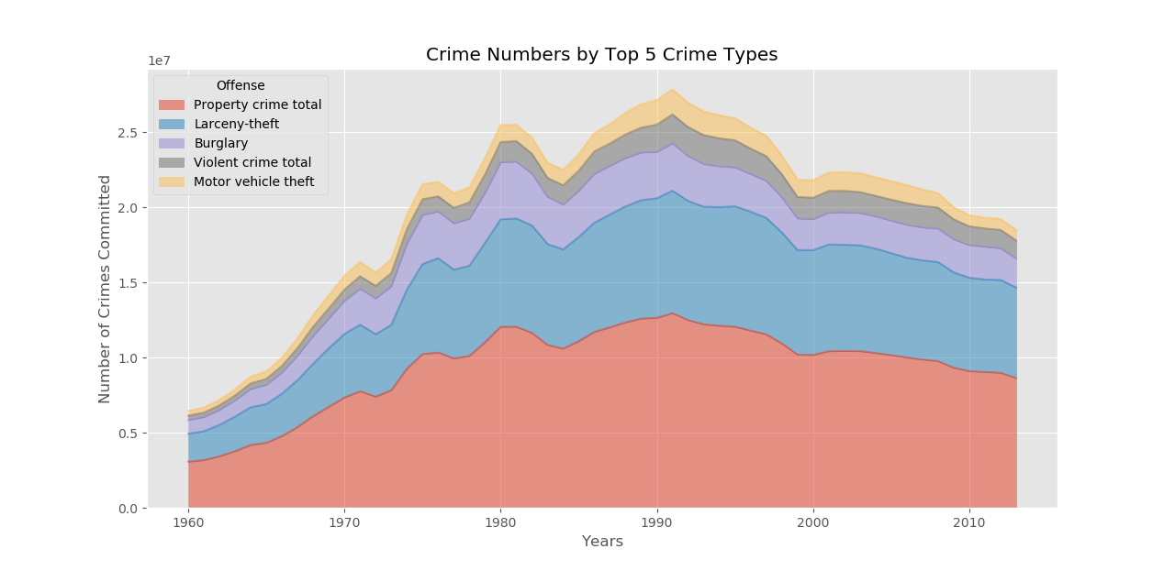

1. **Victimization**:

The victimization survey is an interesting one, primarily because it focuses on the demographics of the victimized rather than the perpetrator. But conducting these surveys at the personal or at the household level, the BJS is able to discern the types of individuals or households being targeted for certain types of crimes. Here, I have chosen merely to portray frequencies of crimes reported by individuals, out of a sample of 60,000 persons. What we find again here is a rather heartening picture. From their peak in the early 90’s, as seen in the previous survey, crimes, such as simple assaults, came down 3-fold, from around 3000 in 1993 to 1000 in 2013, only to see a slight uptick post 2016. Other violent and theft related crimes – such as rape, robbery, theft, assault – also seem to have come down from their peak in the early 90s, and seem to have bottomed out post 2000s.

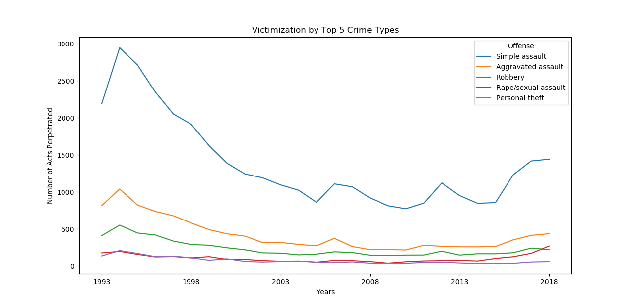

1. **Arrests**:

The number of arrests, while telling a similar story, sometimes seem to produce clues that run counter to the above graphs. Namely, the fact that arrests, based on aroused suspicion do not always result in being booked for a crime. Besides, the highest growth in arrests for any given category, comes from drug related crimes. Meanwhile bookings for drug-related criminal activity show nowhere near the top.

The overall story this tells is that crimes related to larceny and property theft have come way down since the 1990s, as have arrests of thieving criminals. Drug related crimes on the other hand, have spurred some activity in the number of arrests. While ‘driving under the influence’, the only real life threatening category, has slowly declined over the years since the 1980s, the arrests due to drug abuse, and possession have gone way up since the 1980s, peaking in 2005, and declining ever since.

What drug policies in the USA could have led to this sharp decline in drug related arrests post 2005? Was it an actual decline in usage, that is on the perpetrators end? Or was it more of a decline in policing such charges? That is a question for subject matter experts. As it the legalization, versus regulation debate. That too is an extremely nuanced discussion I was one listening to on the ‘New Books Network’ podcast. I would recommend the podcast series to anyone interested in public policy.

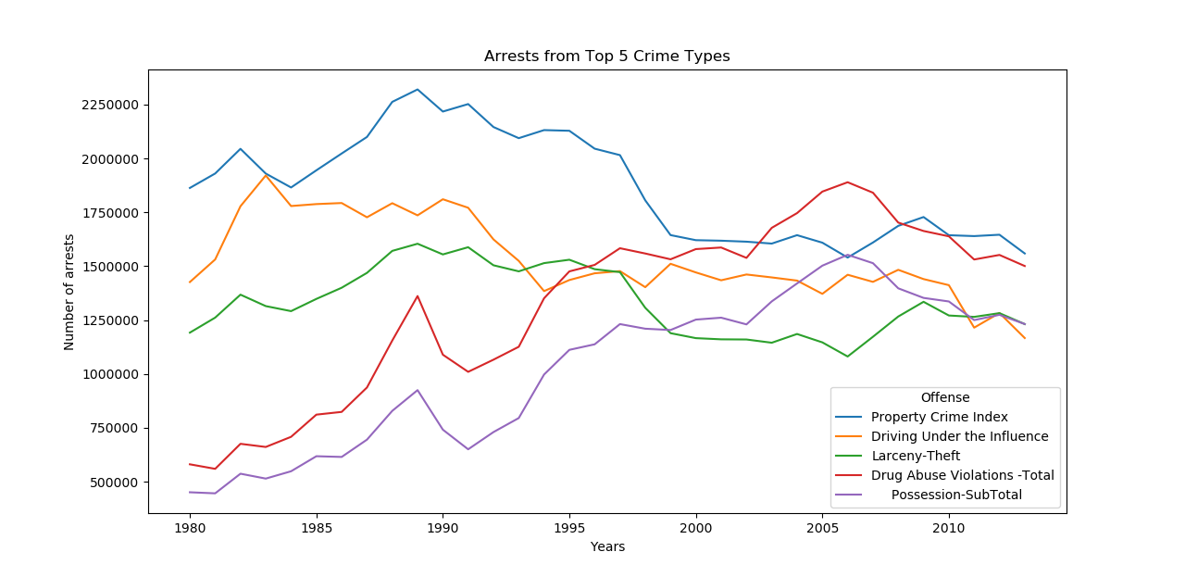

1. **Incarceration** **Numbers**:

And lastly, we come to the metric we have all heard so much about. I would be careful to tout John Oliver mainly because he falls under the purview of some of the shock journalism of mass media. But some of his pieces on prison reform – mind you, a bipartisan issue – have brought light to overloaded prisons. Likewise, my attending seminars on reintegration reminded of the need to help prisoners overcome their lapses in education growing up.

Succumbing to the pernicious effects of peers, we have a flurry or an array of government policies, and research studies conducted on the subject. Everything ranging from the effects of body cameras on crime, to the effects of ban the box on equitable hiring. Now, with the advent of AI we have a steadily growing debate about algorithmic sentencing, and risk scoring perpetrators of past crimes to prevent future ones. Moreover, this leads to the debate on gaps in the data. Or minorities automatically shown to be a greater risk due to their overrepresentation in the correctional system.

I won’t mention the movie minority report here, because I haven’t seen it, but john oliver riffed on it, again. Anyway, I’d known of it’s premise, and people like Cathy O’ Neil have been among the first to bring attention to algorithms skewed due to their training data.

Below, we see a growing number of people held in correctional facilities all the way from 1978 to 2010, and only declining slightly since. While, obviously, still far outnumbering the numbers of prisoners released, and growing at a fast rate than prisoners released, as seen in their slopes, releases also grew through to 2010. There was, however, a slight decline since. Indicating that if state correctional facilities are unable to hold capacity, contractors may pick up the slack.

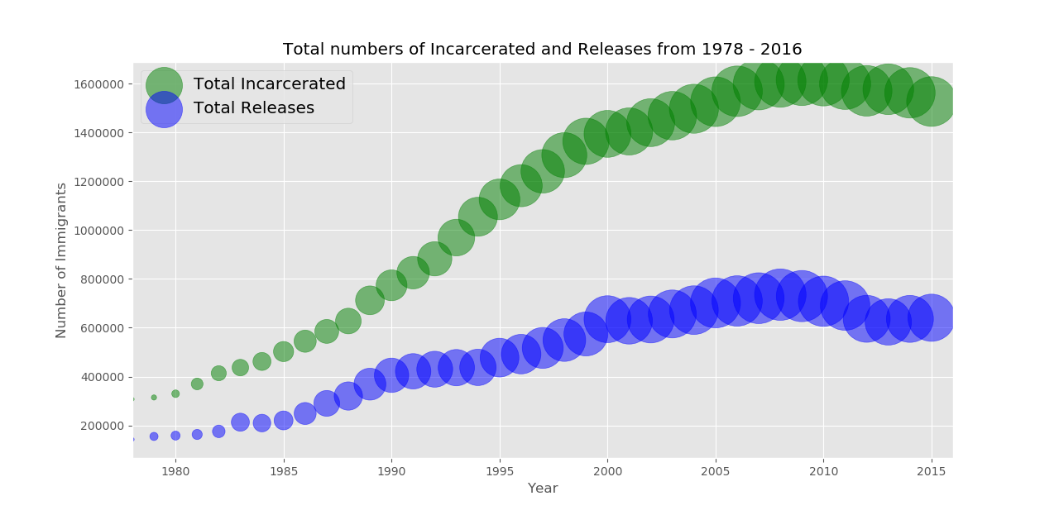

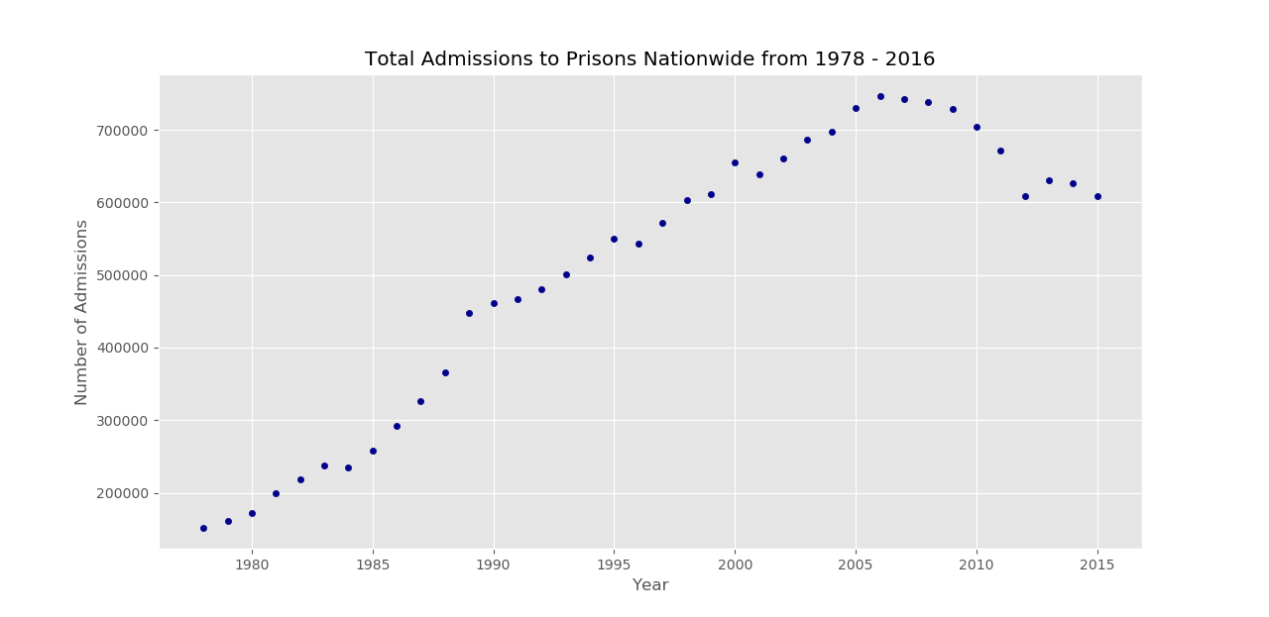

Total admissions to prisons nationwide, another offshoot of the prison populations data, saw a surge all the way through to 2008. Then, following the recession, nationwide facilities both federal and at the state level may have found better uses for their resources in helping banks rebuild their stature. Regardless, the trends in admissions has stuck. And we are glad that state resources are not being overburdened in what can only be deemed to be a very unproductive activity or environment.

Conclusion:

We can only hope that empathy with the underprivileged with continue to grow in modern times, and that prisoner reform, reintegration and reeducation will be prized above a command and control approach by both sides of the aisle.

To foster social mobility is to increase the size of the pie!